Name :Sk.Kashifa

Registration no :192121135

1. book Management system

Class diagram :

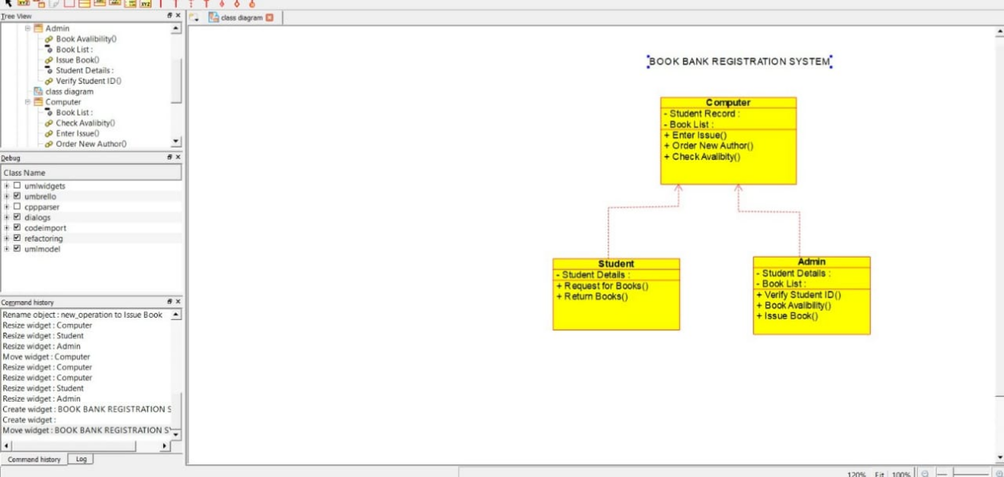

Collaboration diagram :

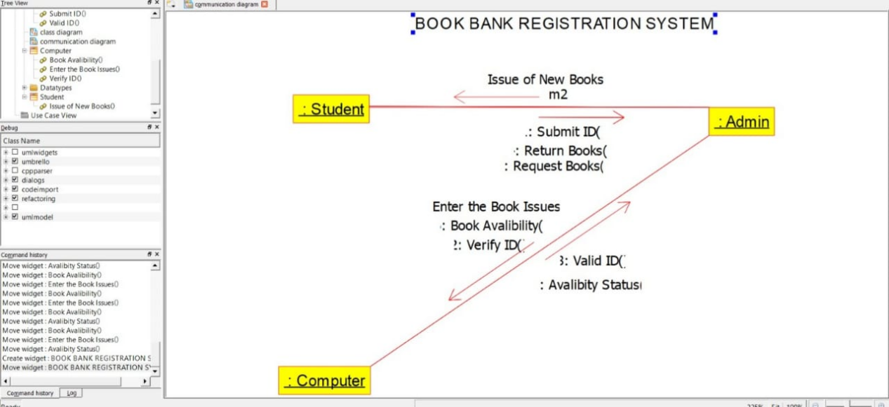

Sequence diagram :

